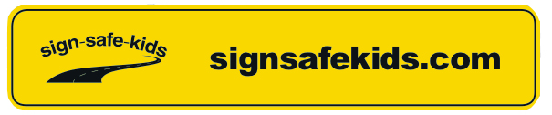

YOUR SCHOOL LETTERHEAD

Dear Parents and Carers,

To ensure our afternoon pick-up queue continues to move safely and efficiently, our school community uses a Sign Safe Kids Car-ID system for all our carline families.

The CarID unit will attach to your passenger visor and last from Kindy to Year 6. It is designed to display your name clearly for the safety and convenience of our duty staff.

If you will require a new or a replacement CarID for the upcoming year, please complete and return this form to the School Office and the cost of $16.95 + GST (per CarID) will be added to your next school account.

If you already own a CarID, there is no need to return this form.

Yours Sincerely,

**Please complete this form in BLOCK LETTERS**

Family name to appear on the Car-ID: _________________________________________

Please circle the quantity required: [ 1 ] [ 2 ] [ 3 ] [ 4 ]

Eldest child’s name and class: ________________________________________________

*(your Car-ID will be addressed to and sent home via this child’s class)*

I give permission for the total of the above to be added to my school account [ ] *(please tick)*

Parents Signature: ________________________________________________

*\* You will be charged according to the quantity ordered @ $16.95 per unit inclusive of GST*